- The working title of your project
Carbon & Forests Dashboard: Deforestation and CO₂ Emissions
- Which UN Sustainable Development Goal(s) are you aiming to contribute to with your project? How could your project contribute to that goal?
Goal 13: Climate action & Goal 15: Life on land
This project will facilitate the exploration and comparison of territorial CO₂ emissions and deforestation across countries and over time. By turning these datasets into searchable country pages, rankings, cross-dataset comparisons, users can identify trends, supporting education and more informed conversations about climate mitigation and forest conservation.
Hopefully this will also help people realize the harm of deforestation and take actions to contribute to the protection of trees, since CO2 concentration rise has a direct negative impact on human, and the Earth as a whole.

- Each person on your team will be responsible for one “full-stack” feature, meaning from the data to the HTML. A feature is some way that the user interacts with the data, such as “look up all the information about a book by its title” or “find books published in the specified range of dates. Some features can deal with just one of your datasets, but at least one should cut across the datasets (since that is the point of having two).
- List out each team member and what their feature will be.
- For each feature, include at least one user story and the acceptance criteria
Feature:
- Description of the purpose of the website & Referable data to further look at if interested in the topic.
  - User story: As a general person interested in sustainability related topics, I can read through the description and further data so that I know what this website wants to show us and have something more to look at if I find myself interested.
  - Acceptance criteria: Highlighted respectively at the start and end of the website individually, normal font size; neutral tone
- Graphics: World map that shows the correlation between deforestation and CO2 emission from 2000-2025
  - User story: As a person interested in general deforestation and CO2 emissions, I can use the sliding bar to visualize the development or improvement through time of how strongly deforestation is impacting CO2 emissions.
  - Acceptance criteria: Shows different level of severness of countries through color shading and a sliding bar that compares 2 different eras
- Scatter Plot: user selects a year, x-axis(CO₂), y-axis(Deforestation), each point is a country

- Search Bar for Independent Country Data:
  - User Story: As a user, I want to search up each country to independently understand how each country is being affected by deforestation and how the effects of deforestation play a role in carbon emissions without the clutter of a map or scatterplot.
  - Acceptance Criteria:
    - Throw out information about the changes in their forests.
    - Throw out information about the changes in their CO₂.
    - Show their tree land coverage.
    - Country ranking.

- Metadata for the (at least) two datasets from the research guide (URL, date downloaded, authorship, exact name and version, terms of use, suggested citation)
- If you’re having trouble filling out the following fields for your dataset, it may be a sign that you need to double-check the source of your dataset.
Deforestation and Forest Loss
https://ourworldindata.org/deforestation
Food and Agriculture Organization of the United Nations (2025) – with major processing by Our World in Data. “Annual change in forest area” [dataset]. Food and Agriculture Organization of the United Nations, “Global Forest Resources Assessment 2025” [original data].
Source: Food and Agriculture Organization of the United Nations (2025) – with major processing by Our World In Data
https://ourworldindata.org/grapher/deforestation-share-forest-area.csv
(accessed on Jan 10, 2026)

CO2 and Greenhouse Gas Emissions
https://ourworldindata.org/co2-and-greenhouse-gas-emissions
Hannah Ritchie, Pablo Rosado, and Max Roser (2023) - “CO₂ and Greenhouse Gas Emissions” Published online at OurWorldinData.org. Retrieved January 13, 2026 from: 'https://ourworldindata.org/co2-and-greenhouse-gas-emissions' [Online Resource]

Pablo Rosado, Hannah Ritchie, Max Roser, Edouard Mathieu, and Bobbie Macdonald (Our World in Data) – “CO2 and Greenhouse Gas Emissions” [dataset]. Our World in Data.
Source: Our World in Data (compiled and documented by the authors above).
https://owid-public.owid.io/data/co2/owid-co2-data.csv
Code & documentation: https://github.com/owid/co2-data

- A pencil-paper sketch “mock up” of what you are hoping your final webpage could look like. Dream big! Get excited!
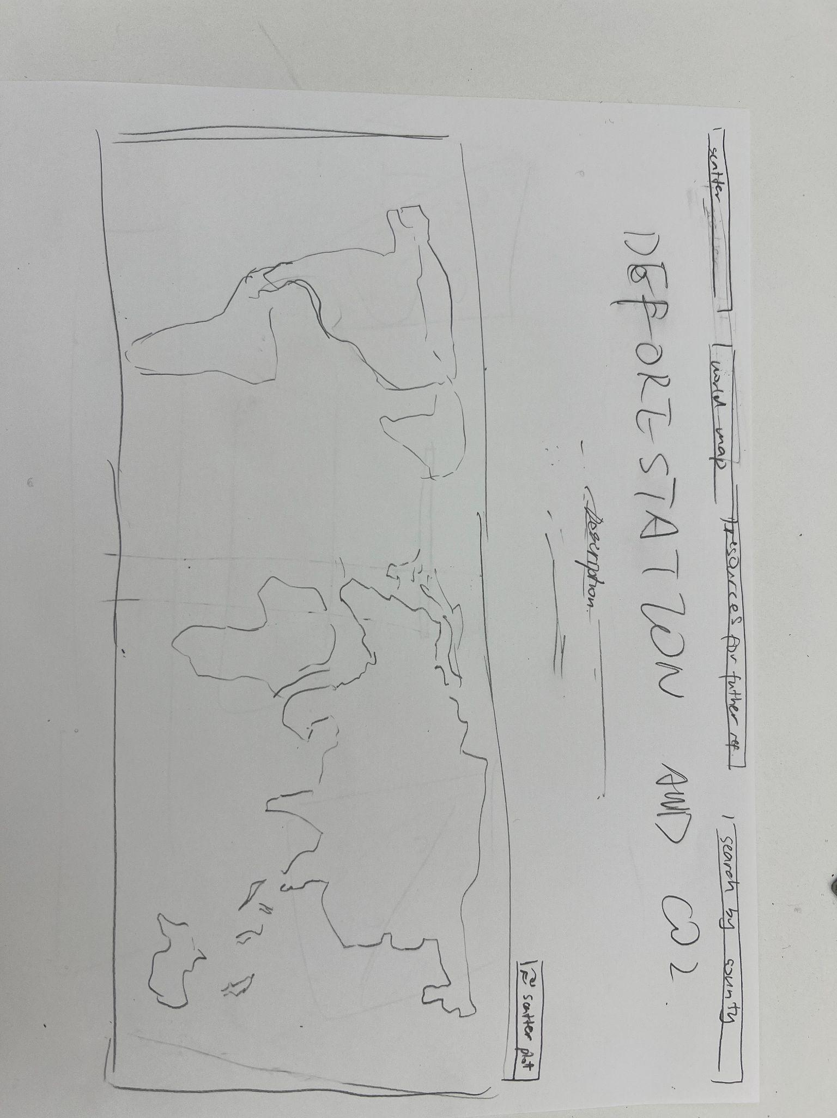
- The story of how you found the datasets. Who found them? Why is your team excited about them? Be honest, I just want to know.
We chose deforestation because forest loss is directly related to biodiversity and climate impacts (SDG 15 +13), and we chose CO₂ per capita because it is a widely used way to compare emissions responsibilities across countries. We are excited because combining these datasets would build a comparison tool to explore whether high-emitting countries also show high deforestation rates.

